Richard Walter

RJWALTER75@GMAIL.COM | SURVEY ASSITANCE

SURVEY ASSIST

a PYTHON APPLICATION FOR SURVEYORS

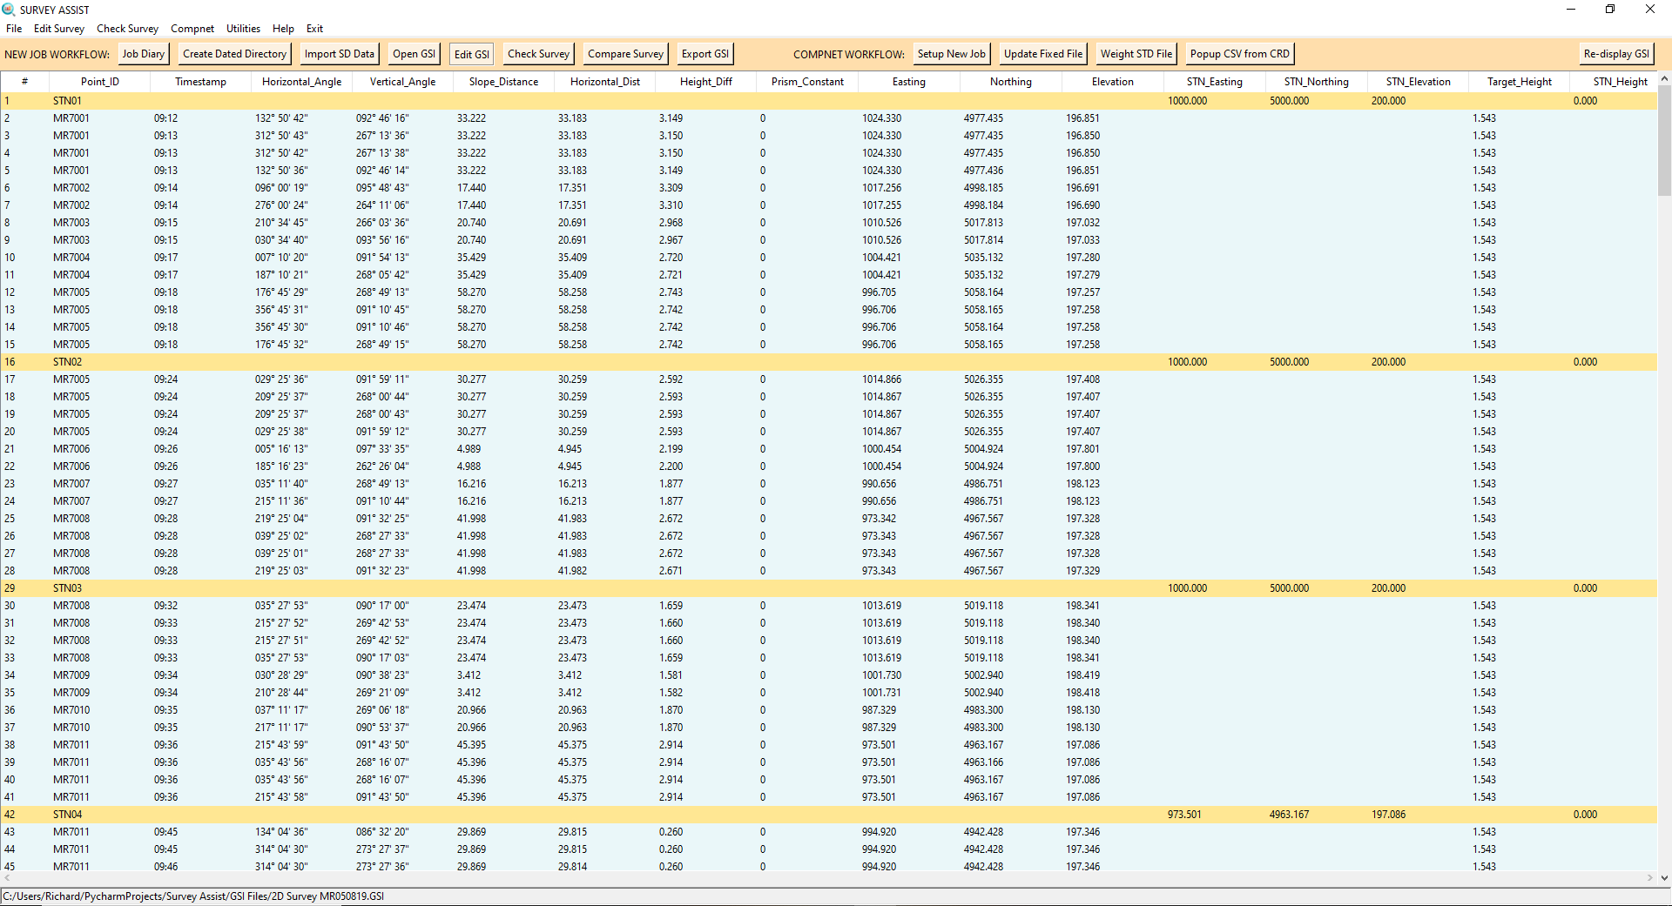

### What is Survey Assist and why use it?

Survey Assist is a python application that makes it easier to perform survey calculations on survey data gathered in the field. The benefits are:

1. **Faster and easier** to perform survey calculations and related functions
2. **Reduction in errors** through automation of tasks
3. **Easily check for survey errors** and fix them prior to processing in CompNet or a survey result sheet
4. **Easier to debug** **and fix problems** due to an ‘easy to read and edit’ user interface
5. **Codebase that is easier to maintain and add new functionality** since all functionality is within one program that’s written in a ‘object orientated’ pythonic style

### How do I install Survey Assist?

Survey Assist is already installed on the shared network drive (\\Colsyd-fil01\depts\Cordeaux\Surv_SD\Functions\Survey Functions\Custom Applications\Python\Survey-Assist-master). You just need to create a desktop short-cut of ‘main.py’ and rename the shortcut to whatever you want (e.g. Survey Assist). You also need to install Python 3 onto your computer if it is not already installed.

### How do I use Survey Assist?

Survey Assist has a number of functions and utilities that can help you with your survey field calculations. The most common ones are centered around ‘workflow’ bars, which provide one-click access, in a suggested order, to process the survey data. There are two workflow bars in Survey Assist, one for processing a new job, and another for CompNet processing.



Let’s discuss each of these functions individually.

### NEW JOB WORKFLOW BAR

JOB DIARY

The first suggested task after getting back from the field is to create a job entry in the job diary. This screen is exactly the same as before. The job diary is the only part of Survey Assist that was not written completely from scratch.

CREATE DATED DIRECTORY

Next, we create a dated directory for the job. This opens up a windows dialog asking you to select the job directory.

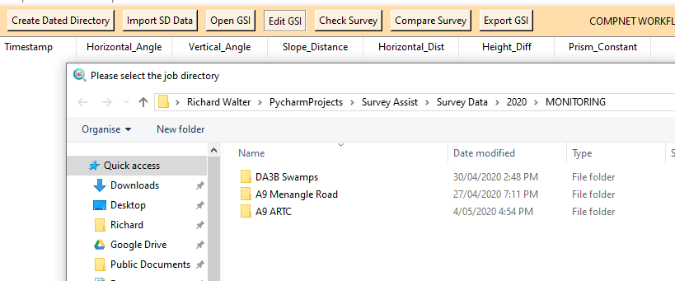

IMPORT SD

Next, insert the SD card containing the day’s survey data and click ‘Import SD’. This will automatically transfer all the day’s GPS and TS files to the dated directory you created above. A backup of any GSI file is automatically created in the ‘EDITING’ folder of the dated directory. All future GSI editing should be based on files in this directory.

OPEN GSI

This will display the GSI in a format that is easier to read, interpret and visually check for any survey errors.

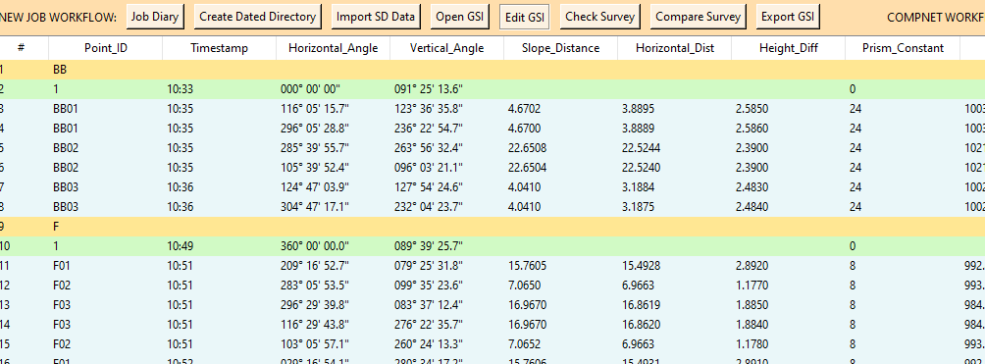

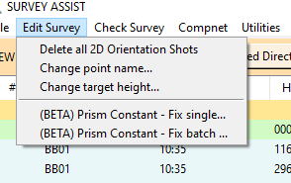EDIT GSI

Survey Assist makes it easy to clean and edit the GSI if required:

* Delete any selected lines using the ‘delete’ key.
* Delete all 2D orientation shots from the ‘Edit Survey’ menu.
* Change point name of selected lines from the’ Edit Survey’ menu.
* Change target height of selected lines from the ’Edit Survey’ menu.
* Update the prism constant of selected lines, or based on a prism constant batch file from the ’Edit Survey’ menu.

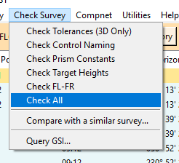CHECK SURVEY

Survey Assist analyses the GSI for a number of possible issues, and warns the user if a problem is detected.

The ‘Check Survey’ buttons checks for all possible issues. Alternatively, we can check for specific issues from the ‘Check Survey’ menu.

Let’s have a look at each one of these individually.

**CHECK TOLERANCES**This checks that the control and change points are all within a specified tolerance. Survey tolerance is specified in the settings.ini file which is stored in the ‘Survey Config’ folder located in the programs root directory. Any control/change points outside of this tolerance are flagged and highlighted yellow. In the case below, an issue with change point MR7098 is flagged. In this case, the wrong change point was accidently shot.

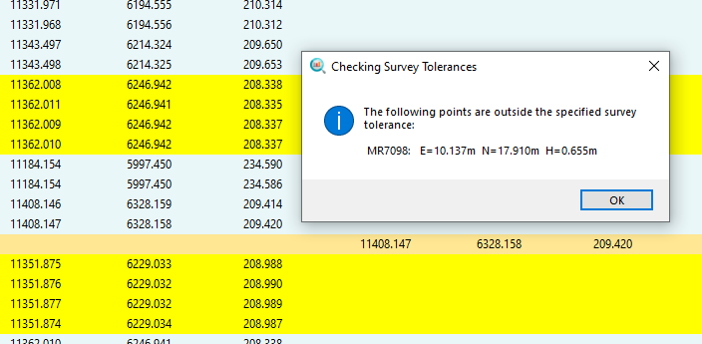

**CHECK CONTROL NAMING**This checks for a number of control naming issues, and provides a warning if an issue is detected:

1. Flags any shots labelled 'STN' that don’t appear as a setup
2. Flags points from each station that contain the Point ID as the station name.
3. Flags any shots containing a ‘STN’ label that does not appear as a station setup

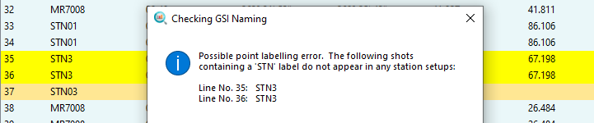

**CHECK PRISM CONSTANTS**Flags a warning to the user if a Point ID has more than one prism constant.

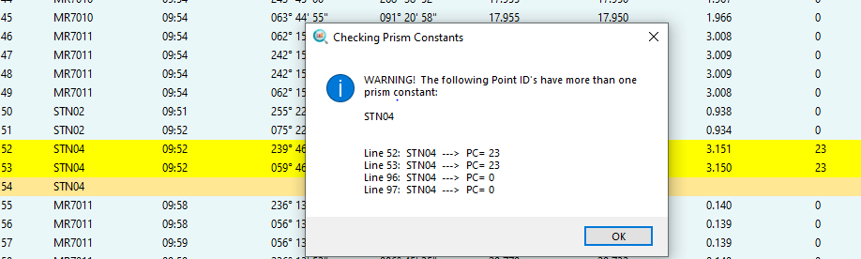

**CHECK TARGET HEIGHT**Flags a warning to the user if the same Point ID was shot with a different target height.

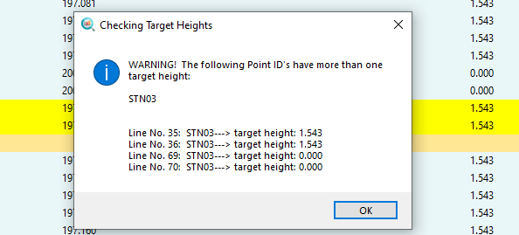

**CHECK FL-FR**Flags are warning to the user when the difference between a face-left and face-right shot exceeds a specified tolerance.

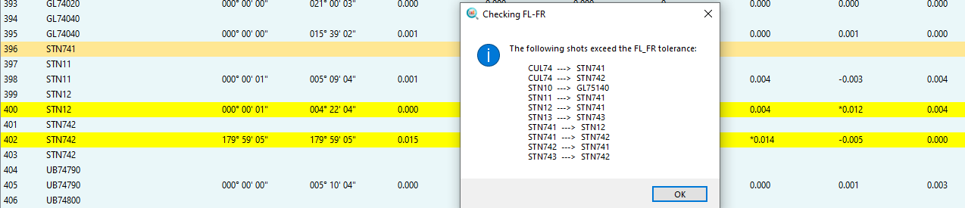

**CHECK DOUBLE-DOUBLES**Checks that 2 double shots were taken for each change point on a 2D line.

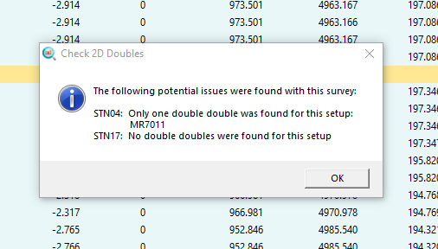

**COMPARE SURVEY**  
This useful check allows the user to compare the current GSI with another GSI. Any difference in point naming, prism constant and target heights between the two surveys is flagged.

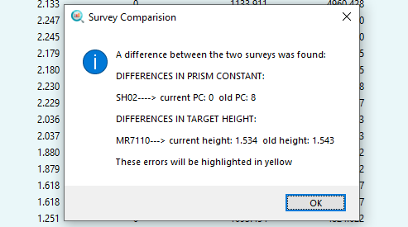

**EXPORT GSI**  
This creates a sorted GSI file along with a corresponding CSV file that is in a format ready to paste into an excel survey calculations sheet. An option to open the csv file is provided.

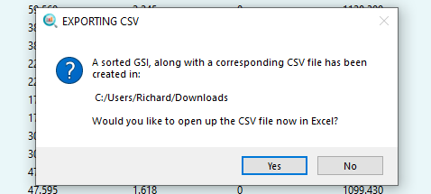

### COMPNET WORKFLOW BAR



SETUP NEW JOB

This utility asks the user to select the GSI he would like process in CompNet, and then copies it over to the LS/RAW DATA directory. It also creates a CompNet job folder in the LS/DATA directory.

UPDATE FIXED FILE

When you are ready to update the fixed file coordinates in CompNet, run this utility to automatically apply the new coordinates based on an ASC, CRD, or STD file.

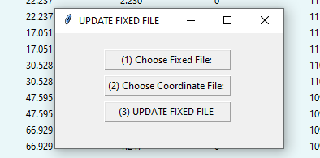

WEIGHT STD FILE

This utility applies a specified weighting to a CompNet STD file.

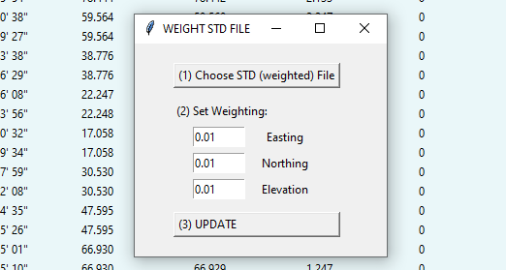

Copy Job to Dated Directory

This function copies the CompNet Folder and CRD output to the dated directory that contains the original GSI.

POPUP CSV FROM CRD

This opens up an excel version of the CompNet CRD output file in a ‘ready to paste’ format

### JOB TRACKER BAR

Survey Assist also contains a job tracker bar that can be displayed from the menu item ‘Job Tracker->Track/Create a Job’. From this menu you can also open up the job tracker in excel rather than displaying the Job Tracker within Survey Assist.



The job tracker bar has two functions. From here you can enter a new job to track, fill in the necessary details and save the job to excel. You can also track an existing job from the drop-down menu. Updated the job details and then hit the ‘Save Job’ button to update the jobs details.

### OTHER UTILITIES

Survey Assist contains are number of other utilities that are useful in different circumstances:

PRINT GSI: Creates a printer friendly version of the GSI in excel (File menu)

CREATE JOB DIRECTORY: Creates a new job directory (File menu)

CREATE MONITORING FILES: Creates survey monitoring files based on the current GSI (File menu)

**QUERY GSI**: Survey Assist stores the GSI in a database. This allows database queries to be performed (Check Survey menu)

**COMPARE CRD:** Compares two CRD files and flags any differences based on a user-specified tolerance (CompNet menu)

**CREATE CONTROL ONLY GSI:** Creates a GSI containing only control. Useful when debugging a survey (CompNet menu)

**COMBINE/REORDER GSI FILES:** Creates a single GSI based on multiple GSI files that can be sorted alphabetically or based on a sorted configuration file (CompNet menu)

**CREATE POPUP CSV FROM ASC:** Opens up an excel version of an ASC file in a ‘ready to paste’ format (Utilities menu)

**CREATE PRINTABLE LIST OF CHANGE POINTS:** Opens up a word document containing a list of change points based on the current GSI (Utilities menu)